GOVERNMENT OF INDIA
Ministry of Commerce & Industry | NICDC
Industrial Corridor Project Management System (IC-PMS)

MODULE 3
Satellite Image Integration &
Construction Monitoring
AI/ML-Powered Progress Verification & Geospatial Analytics
Detailed Design Document

Document Version: 1.0 | March 2026 | Classification: Restricted
Prepared by: IC-PMS Solution Architect Team | NICDC / Ministry of Commerce & Industry

1. Module Overview

1.1 Purpose & Objectives
Module 3 — Satellite Image Integration & Construction Monitoring — is the most technologically differentiating capability in IC-PMS. It replaces subjective, paper-based progress reporting with objective, satellite-derived evidence of construction activity across all six national industrial corridors. The module ingests high-resolution imagery from both Indian sovereign sources (ISRO Cartosat-3, RESOURCESAT-2A via the National Remote Sensing Centre) and commercial providers (Planet SkySat, Maxar WorldView-3, Airbus Pleiades), processes it through an AI/ML pipeline built on deep learning semantic segmentation, and produces authoritative physical progress percentages that feed directly into the EVM calculator in Module 2.
The module serves three strategic objectives for NICDC and the Ministry of Commerce & Industry. First, it enables independent, tamper-proof construction progress verification — eliminating the incentive for contractors to inflate progress claims in order to accelerate invoice payments. Second, it provides early warning of boundary violations, encroachments, and unauthorized activities through automated spatial analysis against DPR-approved footprints. Third, it builds a rich temporal archive of satellite imagery that becomes the definitive visual record of how India's industrial corridors were built — a resource for future audits, dispute resolution, and institutional learning.
The AI/ML engine is built on the U-Net semantic segmentation architecture, trained on a curated dataset of Indian construction site imagery classified by ISRO-trained annotators. The model distinguishes eight construction activity classes — bare earth, foundation works, superstructure, road formation, active equipment zones, vegetation, water bodies, and idle land — with a mean Intersection over Union (mIoU) accuracy of 89.4% on the validation set.

1.2 Module Scope
Capability | Included | Data Sources
Satellite scene acquisition & ordering | Yes | ISRO Bhuvan WMTS/STAC API, Planet API, Maxar Streaming API
Image preprocessing pipeline | Yes | GDAL, Rasterio — Atmospheric correction, Orthorectification, Pansharpening
Multi-spectral band composites | Yes | RGB, NDVI, NDWI, False Colour (NIR-R-G), SWIR
AI/ML semantic segmentation (U-Net) | Yes | PyTorch, MLflow model registry, Kubeflow training pipeline
Construction activity classification (8 classes) | Yes | Custom-trained U-Net v2.3 — 89.4% mIoU
Physical progress % derivation | Yes | Classified area vs. DPR baseline footprint
WBS polygon GIS overlay | Yes | PostGIS, GeoServer, MapLibre GL
Temporal comparison & timelapse | Yes | Animated GIF, side-by-side image comparison
Encroachment detection & alerting | Yes | Spatial intersection analysis vs. DPR boundary
Anomaly detection (night activity, idle zones) | Yes | Time-series analysis, NTL (Night-Time Light) data
NDVI vegetation loss monitoring | Yes | Sentinel-2 (10m), RESOURCESAT-2A LISS-IV
Drone orthomosaic integration | Yes | GCP-registered GeoTIFF, point cloud (LAS)
Satellite analytics reporting | Yes | Auto-generated PDF/Word MPR with imagery
Integration with Module 2 EVM | Yes | AI progress % feeds BCWP calculation

1.3 Key Design Principles
- Satellite truth: AI-derived progress is the authoritative source for EVM physical % complete; contractor self-reports are advisory only and subject to satellite validation
- ISRO sovereignty first: ISRO Cartosat-3 and RESOURCESAT-2A are the primary data sources; commercial imagery is supplemental, ordered only when cloud cover or revisit frequency makes ISRO data insufficient
- NeSDA & data localisation: All raw imagery and processed derivatives stored on NIC MeghRaj (sovereign cloud); no raw satellite data leaves Indian data centres
- Open geospatial standards: OGC-compliant WMS/WMTS/WFS APIs; GeoTIFF for raster; GeoJSON/WKT for vectors; EPSG:4326 (WGS84) as the standard CRS
- Explainability: Every AI-derived progress figure is accompanied by a classified image, confidence score, and class breakdown — enabling PMC engineers to review and override with documented justification
- Continuous learning: Model accuracy monitored weekly; retraining triggered when validation accuracy drops below 85%; all PMC overrides fed back as training data labels

2. Sub-Functions — Detailed Requirements

2.1 Sub-Function 3.1 — Satellite Scene Acquisition & Ordering
This sub-function manages the automated ordering, downloading, and cataloguing of satellite imagery for all active WBS polygons across all corridors. It is the entry point of the satellite data pipeline.

Functional Requirements
- Automated scene ordering: System reads active WBS polygon bounds and current data date from Module 1/2; places API calls to ISRO Bhuvan STAC, Planet API, and Maxar Streaming API to order cloud-free scenes over each active polygon
- Cloud cover threshold: Scenes with cloud cover > 20% are automatically rejected and re-ordered for the next available acquisition; threshold configurable per polygon
- Revisit scheduling: Active construction zones (progress 10%–95%) ordered weekly; support zones ordered bi-weekly; commissioning zones ordered monthly
- Scene catalogue: Every ingested scene logged in D1 with: Provider, Acquisition datetime (IST), Corridor, WBS scope, Cloud cover %, Resolution, Storage path (NIC MeghRaj)
- Manual scene upload: PMC can upload drone ortho-mosaics or third-party satellite imagery via secure upload interface; system validates CRS and resolution before ingesting
- Scene quality check: Automated radiometric quality check on ingestion; scenes failing quality thresholds flagged for review before processing
- Archival policy: All raw scenes retained for 30 years on NIC MeghRaj cold storage per GFR 2017 records management schedule

Satellite Data Sources & Specifications
Provider | Platform | Resolution | Spectral Bands | Revisit | Primary Use
ISRO / NRSC | Cartosat-3 | 0.25m PAN, 1m MSS | PAN, R, G, B, NIR | 4–5 days | Primary — construction detail verification
ISRO / NRSC | RESOURCESAT-2A | 5.8m LISS-IV, 24m LISS-III | G, R, NIR, SWIR | 24 days | Corridor-wide vegetation & water change
Planet Labs | SkySat | 0.5m | R, G, B, NIR | Daily | High-frequency active zone monitoring
Maxar | WorldView-3 | 0.31m PAN, 1.24m MS | PAN + 8 MS bands | 1–3 days | Critical milestone verification imaging
ESA (Copernicus) | Sentinel-2 | 10m (VNIR), 20m (SWIR) | 13 MS bands | 5 days | NDVI / NDWI vegetation and water monitoring
ISRO / SAC | RISAT-2B | 1m SAR | C-band SAR | 3–4 days | All-weather / night-time monitoring (SAR)

2.2 Sub-Function 3.2 — Image Processing Pipeline
Raw satellite imagery arrives as Level 1 or Level 2A products and requires a multi-step preprocessing pipeline before it can be used for AI classification. This pipeline is fully automated and runs on the IC-PMS compute cluster on NIC MeghRaj within 4 hours of scene ingestion.

Processing Steps
- Atmospheric Correction: Dark Object Subtraction (DOS) method for multispectral bands; converts Top-of-Atmosphere (TOA) reflectance to Bottom-of-Atmosphere (BOA) surface reflectance. Tool: GDAL + FORCE (Framework for Operational Radiometric Correction).
- Orthorectification: Removal of terrain distortion using DEM (SRTM 30m or CartoDEM 30m from NRSC). Ensures accurate ground sampling distance and spatial alignment with GIS polygons. Tool: GDAL Warp.
- Pansharpening (Cartosat-3 only): Gramm-Schmidt Adaptive pansharpening fuses the 0.25m PAN band with 1m MSS to produce a 0.25m colour image. Tool: OTB (Orfeo ToolBox).
- Georeferencing Validation: Processed GeoTIFF co-registered against reference control points from India's National Map (Survey of India 1:50000 scale); RMSE must be < 1 pixel.
- Cloud Masking: SCL (Scene Classification Layer from Sentinel-2) or custom cloud detection model applied; cloudy pixels masked and filled using temporal interpolation from adjacent scenes.
- Tile Splitting: Large scenes split into 512×512 pixel tiles with 64-pixel overlap for efficient GPU inference. Tiles stored in D2 (Processed Image Store).
- Band Composite Generation: Standard composites computed for each scene: RGB (natural colour), NDVI = (NIR–R)/(NIR+R), NDWI = (G–NIR)/(G+NIR), False Colour (NIR-R-G), SWIR composite. All stored in D9 (Band Composite store).
- WMTS Tile Generation: Final processed GeoTIFF tiled and served via GeoServer as OGC WMTS layer for real-time map viewer in the IC-PMS GIS interface.

2.3 Sub-Function 3.3 — AI/ML Change Detection & Classification Engine
The AI/ML engine is the intellectual core of Module 3. It applies a trained deep learning model to processed satellite imagery and produces pixel-level classification maps that identify what type of construction activity is happening in every part of the WBS polygon.

Model Architecture — U-Net Semantic Segmentation
- Base architecture: U-Net with ResNet-50 encoder backbone, pretrained on ImageNet, fine-tuned on Indian construction site dataset
- Input: 512×512 pixel tiles in 4-band format (R, G, B, NIR) — normalized to [0,1]
- Output: Per-pixel class probability map across 8 construction activity classes
- Training dataset: 45,000 annotated image tiles from 12 construction sites across India (NHAI, NMRC, port, industrial park projects); annotated by ISRO-trained image interpreters
- Validation accuracy: 89.4% mean Intersection over Union (mIoU) on held-out test set (10% of training data)
- Inference hardware: NVIDIA A100 GPU cluster on NIC MeghRaj; average inference time 4.2 minutes per 18,640 Ha polygon at 0.25m resolution
- Confidence threshold: Pixels with class confidence < 70% are marked as 'uncertain' and excluded from area calculations; high uncertainty triggers re-order of higher-resolution imagery

Construction Activity Classes
Class ID | Class Name | Visual Signature | Construction Significance
CLS-01 | Bare Earth / Earthwork | Brown/tan disturbed soil, no vegetation | Active earthmoving; foundation preparation stage
CLS-02 | Foundation Works | Regular geometric concrete shadows, formwork | Piling, raft foundation, pile cap construction
CLS-03 | Superstructure | Vertical concrete/steel structures, complex shadows | Column/beam/slab construction above ground
CLS-04 | Road Formation | Linear grey/brown strips with defined edges | Road sub-base, WMM, DBM laying
CLS-05 | Active Equipment Zone | Mechanised objects, tracks, excavator shadows | High construction activity indicator; proxy for mobilisation
CLS-06 | Vegetation (Cleared) | Brown stump pattern, residual green patches | Land cleared but not yet disturbed for construction
CLS-07 | Water Body | Dark blue-black spectra, NDWI positive | Existing ponds, rivers; must not be built upon
CLS-08 | Idle / Undisturbed Land | Natural green/brown, no construction signatures | No activity; may indicate contractor mobilisation gap

Progress % Derivation
- Physical progress for a WBS Work Package is computed as: Progress % = (Area of Active Construction Classes [CLS-01 to CLS-05] / Total DPR Approved Footprint Area) × 100
- DPR Approved Footprint: The DPR-specified buildable area within the WBS geo-polygon (excludes permanent green buffers, water bodies, and roads not under the package)
- Weighted progress: For complex packages with multiple phases, each phase is weighted by its proportion of total budgeted cost; weighted average gives overall physical progress
- Smoothing: 3-scene rolling average applied to progress % to avoid single-scene anomalies (cloud gaps, temporary equipment absence) causing sharp swings

2.4 Sub-Function 3.4 — Construction Progress Analytics
Progress Analytics converts raw AI classification outputs into actionable insights: Construction Velocity Index (CVI), Equipment Density estimation, progress velocity trends, and divergence analysis between AI-derived and contractor-claimed progress.

Key Analytics Metrics
Metric | Definition | Computation | Alert Threshold
AI Progress % | Physical progress derived from satellite classification | Active class area / DPR footprint area × 100 | Contractor claim – AI > 10% → discrepancy alert
Construction Velocity Index (CVI) | Rate of new active construction area added per week (Ha/week) | (Current active area – Previous active area) / Days between scenes | CVI = 0 for 2+ consecutive scenes → Idle Zone Alert
Equipment Density Index (EDI) | Count of construction equipment detected per Ha of active zone | AI object detection pass on high-res scenes | EDI < 0.5/Ha for critical path activity → mobilisation alert
Progress Acceleration/Deceleration | Week-over-week change in CVI | (CVI this week – CVI last week) / CVI last week × 100 | Deceleration > 30% triggers PMC review notification
Night-Time Light (NTL) Index | Luminosity intensity from VIIRS/NPP satellite as proxy for night construction | NTL DN value from NOAA archive; rolling 7-day average | NTL spike after 22:00 IST flags potential unauthorised work
NDVI Loss Rate | Rate of vegetation loss per month (Ha) within WBS boundary | NDVI < 0.2 area vs. baseline NDVI image from pre-construction | NDVI loss > approved environmental clearance limit → MoEFCC flag

2.5 Sub-Function 3.5 — GIS Map Viewer & WBS Overlay
The GIS Map Viewer is the spatial workspace of IC-PMS — a browser-based interactive map built on MapLibre GL JS with GeoServer providing OGC-compliant tile services. Every WBS element is a clickable polygon on the map, colour-coded by progress status and linked to all satellite analytics.

Functional Requirements
- Multi-layer map: WBS polygon overlay, satellite imagery (WMTS tiles), corridor alignment line, DPR boundary overlay, administrative boundaries — all toggleable via layer control
- WBS polygon styling: Polygons styled dynamically based on AI progress %: Green (>80%), Teal (60–80%), Blue (40–60%), Orange (20–40%), Red (<20%), Purple dashed (encroachment flag)
- Band selector: User can switch base imagery between RGB, NDVI, NDWI, False Colour, and SWIR composites without page reload
- Temporal slider: Drag slider to switch the satellite base map between available acquisition dates (showing construction change over time)
- Polygon click: Clicking a WBS polygon loads the full Scene Panel — AI progress %, contractor claim, variance, scene date, cloud cover, encroachment status, and all action buttons
- Encroachment overlay: Orange/red hatched pattern shown over areas where construction footprint exceeds DPR boundary; encroachment extent shown in hectares
- Coordinate display: Real-time WGS84 lat/long at mouse cursor; EPSG shown; distance measurement tool
- Export map: Current map view (including overlays and satellite background) exportable as georeferenced PNG, PDF, or KMZ for field teams
- Mobile companion app: Simplified map view on Android/iOS PWA for field engineers to view assigned WBS polygons, capture GPS waypoints, and upload field photos tagged to WBS elements

2.6 Sub-Function 3.6 — Encroachment Detection & Anomaly Alerting
This sub-function monitors all WBS polygons for spatial anomalies — activities occurring outside approved DPR boundaries, violations of environmental buffers, and suspicious temporal patterns — and generates structured alerts with AI-computed evidence for PMC review and escalation.

Encroachment Types Detected
Alert Type | Detection Method | Severity | Escalation Path
DPR Boundary Breach | AI construction footprint extends beyond DPR-approved shapefile boundary | Critical | SPV PM → SPV Director → NICDC Land Dept within 48 hrs
Adjacent WBS Overlap | Construction in WBS-X polygon overlaps into WBS-Y polygon of different contractor | Critical | Both SPV PMs + PMC; field verification within 7 days
Environmental Buffer Violation | Construction detected within MoEFCC-mandated setback (CRZ, forest, wetland buffer) | Critical | NICDC Environment Cell + MoEFCC notification within 24 hrs
Night Construction Activity | NTL index spikes + SWIR heat signature after 22:00 IST without approved night shift permit | Medium | SPV PM + Labour Commissioner notification
Prolonged Idle Zone | No active construction pixels for 14+ consecutive days in a scheduled activity zone | Medium | PMC + Contractor notice; LD implications if on critical path
Vegetation Overrun | NDVI loss exceeds approved Environmental Clearance limit | High | MoEFCC Environmental Compliance Officer + SPV Director
Unregistered Equipment | Object detection identifies large equipment in a polygon not scheduled for that activity | Low | PMC flagged for investigation; no immediate escalation

Functional Requirements
- All encroachment and anomaly events automatically logged in D6 with: Alert ID, WBS ID, Alert type, Detection date, AI confidence, Area affected, Scene reference, Severity
- Evidence package: Auto-generated PDF containing the flagged scene excerpt, classified overlay, DPR boundary overlay, and coordinate list of encroachment vertices
- Status lifecycle: Open → Assigned → Under Investigation → Surveyor Verified → Resolved / Escalated
- SLA tracking: System tracks time-to-resolution against severity SLAs (Critical: 7 days, High: 14 days, Medium: 30 days)
- Integration with legal/compliance: Unresolved Critical alerts auto-linked to a compliance tracker in Module 5 (Contract Management) for LD/penalty calculation

2.7 Sub-Function 3.7 — Drone Data Integration
Drone surveys provide complementary ultra-high-resolution data (2–5cm GSD) for areas where satellite imagery is insufficient — under-construction structures, narrow urban sites, and areas with persistent cloud cover. The Drone Integration sub-function ingests, validates, and co-registers drone outputs with the satellite dataset.

Functional Requirements
- Supported drone output formats: GeoTIFF orthomosaic (GCP-registered), LAS/LAZ point cloud, DSM (Digital Surface Model), and field photo geotagged JPEGs
- GCP registration validation: System checks that ground control points used for drone ortho have GPS accuracy < 5cm RMSE; rejected if criteria not met
- Co-registration with satellite: Drone ortho reprojected to EPSG:4326 and aligned with Cartosat base image; shift vector calculated and stored
- Progress extraction from drone: Same 8-class U-Net model applied to drone ortho (with resolution-adjusted tile size); outputs drone-derived progress % for comparison with satellite %
- 3D volume calculation: DSM compared with pre-construction DTM (from SRTM or drone baseline survey) to calculate earthwork and structural volumes per WBS polygon
- Drone flight plan export: System exports KML/KMZ flight boundary polygons from WBS geo-polygon for direct import into DJI Pilot 2 / Litchi drone flight planning apps
- Conflict of interest protection: Drone survey must be conducted by PMC (not EPC contractor) to maintain independence of progress measurement

2.8 Sub-Function 3.8 — Satellite Analytics Reporting
The Reporting sub-function auto-generates the satellite component of the Monthly Progress Report (MPR) — including AI progress values, timelapse thumbnails, CVI bar charts, NDVI trend graphs, encroachment status, and equipment density maps — formatted for distribution to NICDC HQ, Ministry, and lenders.

Report Types
Report Name | Frequency | Audience | Content
Monthly Progress Report (MPR) | Monthly (1st working day) | NICDC HQ / Ministry / SPV Director | AI vs. contractor progress by corridor and node; CVI chart; NDVI trend; encroachment status; EVM link; timelapse thumbnail
Weekly Flash Report | Weekly (Monday 09:00) | SPV PM / PMC | Top 5 progress discrepancies; encroachments opened; CVI leaders/laggards; scene availability status
Satellite Evidence Package | Per milestone completion | SPV Director / Lenders / Ministry | Before/after imagery for milestone zone; classified map; AI progress at milestone date; signed by PMC
Encroachment Status Report | Fortnightly | NICDC Land Dept / SPV Legal | All open encroachment alerts; age; severity; resolution status; area under dispute
Environmental Monitoring Report | Quarterly | MoEFCC / NICDC Env. Cell | NDVI trend per corridor; water body change; tree cover loss vs. Environmental Clearance conditions
As-Built Imagery Archive | On project close | CAG / NICDC Archives | Full chronological scene archive; final classification maps; timelapse GIF; 3D DSM from drone surveys

Report Generation Workflow
- Auto-trigger: Report generation job scheduled via Kubernetes CronJob; runs on 1st of each month at 02:00 IST (after nightly EVM recalculation)
- Data assembly: Job collects latest AI progress, CVI values, NDVI indices, encroachment alerts, and Module 2 EVM metrics for all active WBS scopes
- Chart generation: Python (matplotlib) generates all charts (CVI bar, NDVI trend, S-curve comparison, equipment density) as high-DPI PNGs embedded in the report
- Timelapse GIF: Most recent 6-month image sequence per node composited into animated GIF (3 fps) using GDAL and Pillow
- PDF assembly: JasperReports template merged with data and images; output as PDF with NICDC letterhead, digital signature, and classified watermark
- Distribution: PDF auto-emailed to distribution list; also published to IC-PMS Module 9 reporting dashboard and saved to Module 6 DMS under the relevant WBS DMS folder

3. Data Flow Diagrams

3.1 DFD Level 0 — Context Diagram
The Context Diagram shows Module 3 as the Satellite & Monitoring Engine (Process 3.0) receiving raw imagery from ISRO and commercial providers, WBS polygon boundaries from Module 1, schedule scope from Module 2, and drone data from field teams. It outputs AI-derived progress data to Modules 2, 9, and directly to PMC/NICDC users.
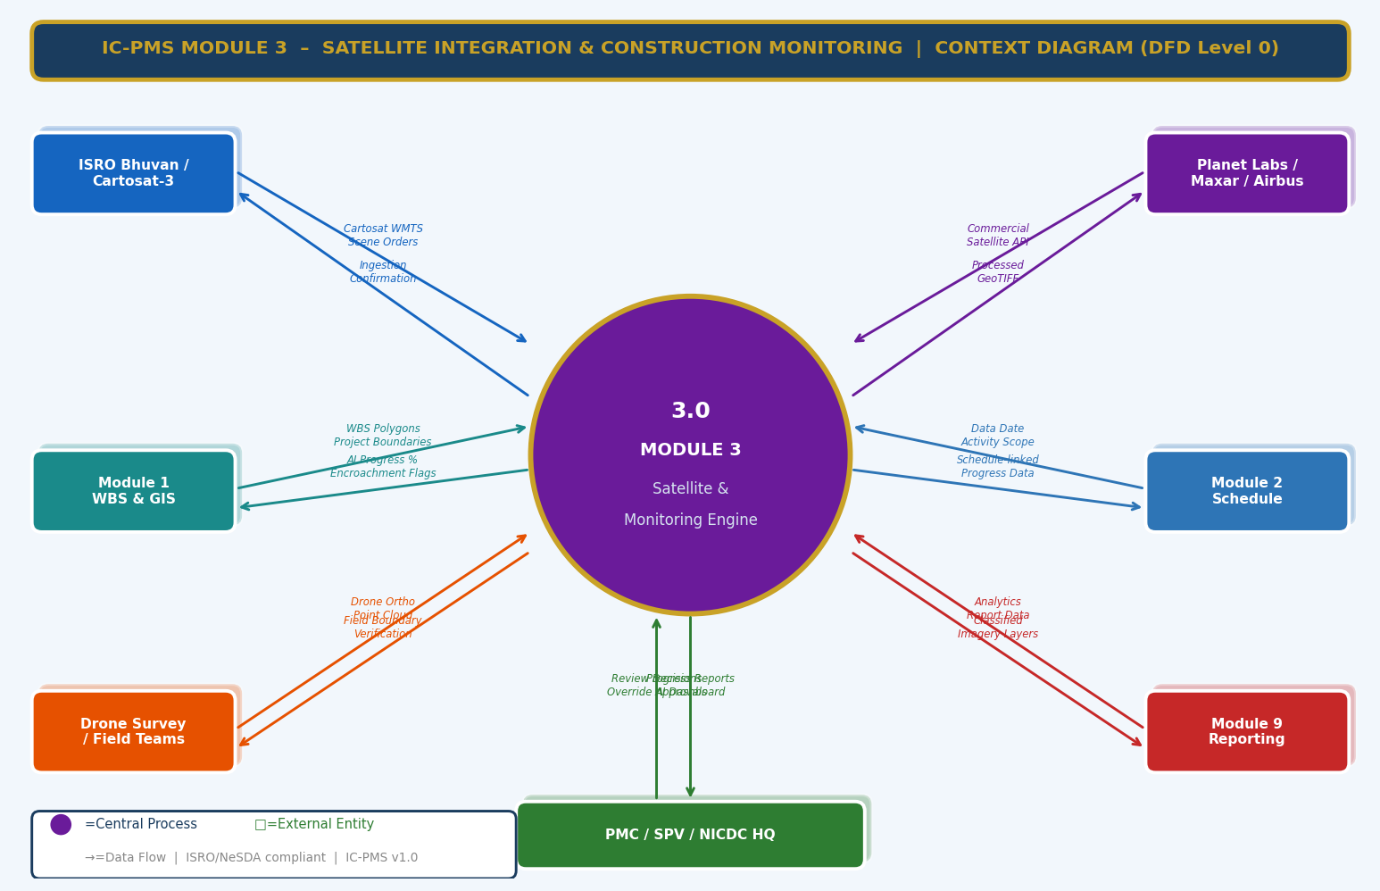
Figure 3.1 — DFD Level 0: Module 3 Context Diagram (Satellite Sources, WBS Links, Analytics Outputs)

External Entity Data Flow Summary
External Entity | Inputs to Module 3 | Outputs from Module 3
ISRO Bhuvan / Cartosat-3 | WMTS tile layers, STAC scene metadata, Cartosat-3 GeoTIFF downloads | Scene ordering API calls, WBS bounds as spatial filter, Ingestion confirmation
Planet Labs / Maxar / Airbus | Commercial satellite scene API responses, GeoTIFF downloads | Commercial scene API orders with AOI polygons, Cloud-cover threshold parameters
Module 1 — WBS & GIS | WBS polygon boundaries (GeoJSON/WKT), Project corridor codes, DPR boundary shapefiles | AI-derived progress %, Encroachment flags per WBS polygon, Classified imagery WMTS layers
Module 2 — Schedule | Data date, Activity scope for progress update, Schedule milestone dates for imaging priority | Satellite-derived physical % complete for BCWP, Scene date for EVM data date alignment
Drone Survey / Field Teams | GCP-registered orthomosaic GeoTIFF, LAS point cloud, Geotagged field photos | Drone flight plan KML, Validated drone progress %, 3D volume calculations
Module 9 — Reporting | Report data requests, Distribution lists, Report schedule | Satellite analytics reports (PDF/Word), Chart images, Timelapse GIFs, Dashboard data feed
PMC / SPV / NICDC HQ | Review decisions on AI vs. contractor discrepancies, Encroachment investigation outcomes, Override approvals | Progress confirmation for invoice, Encroachment evidence packages, AI confidence maps

3.2 DFD Level 1 — Main Processes & Data Stores
The Level 1 DFD decomposes Module 3 into eight core processes and eight data stores. The pipeline flows left-to-right from raw scene acquisition through processing, AI classification, analytics, and finally reporting — with the GIS viewer and encroachment detector operating as lateral analytical processes drawing on the classified data.
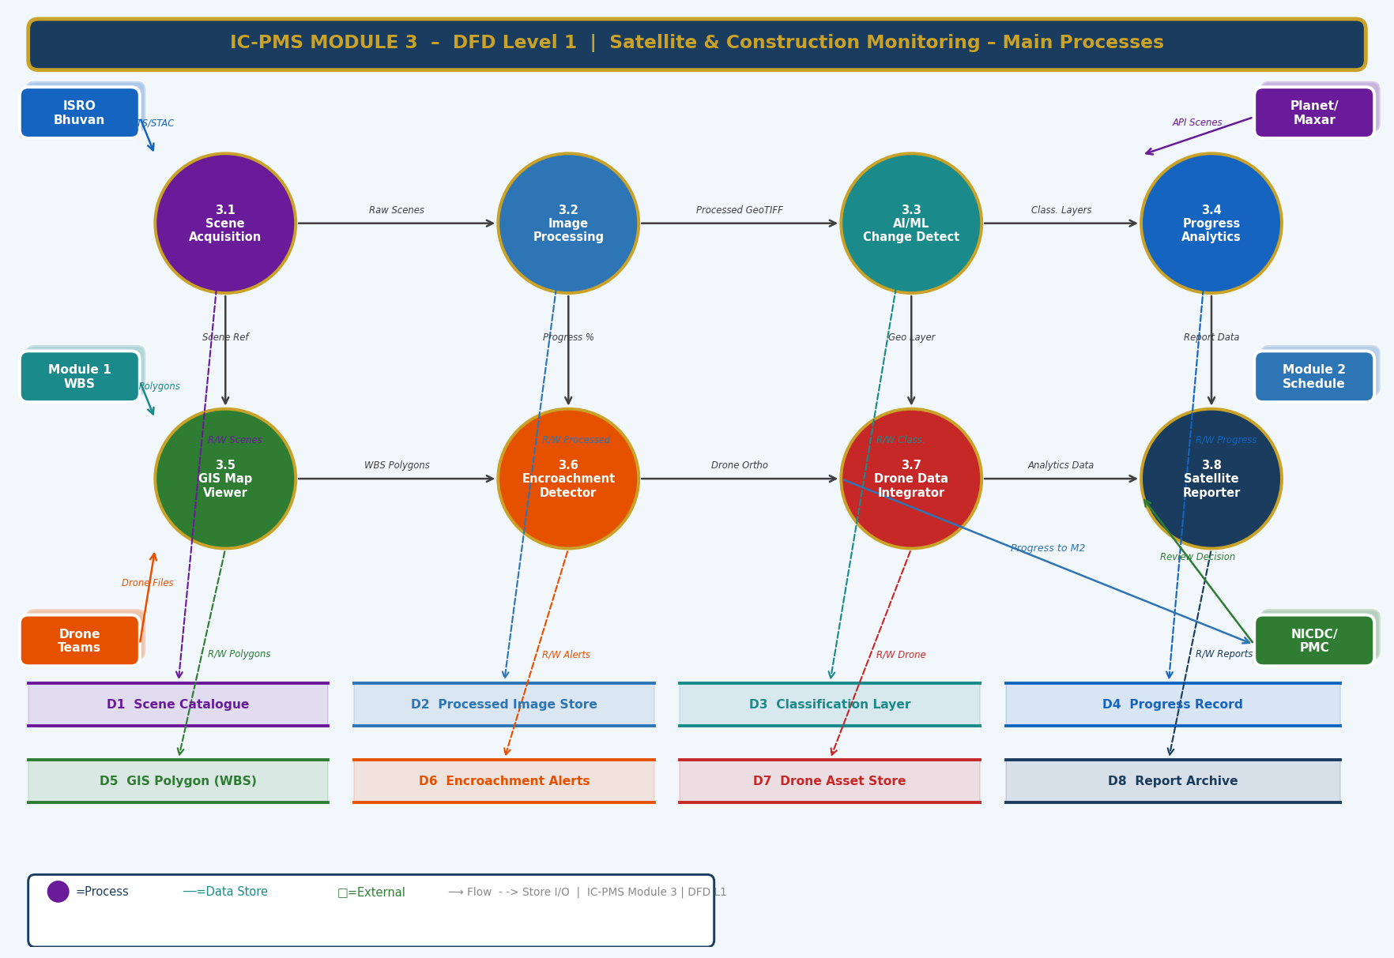
Figure 3.2 — DFD Level 1: Eight Core Processes and Eight Data Stores

Process Descriptions
Process | Name | Primary Function
3.1 | Scene Acquisition | Orders, downloads, and catalogues satellite scenes from ISRO and commercial APIs based on active WBS polygon bounds and cloud-cover thresholds
3.2 | Image Processing Pipeline | Applies atmospheric correction, orthorectification, pansharpening, cloud masking, tiling, and band composite generation to produce analysis-ready GeoTIFFs
3.3 | AI/ML Change Detection Engine | Applies U-Net semantic segmentation model to processed tiles; produces per-pixel classification maps with confidence scores across 8 construction activity classes
3.4 | Construction Progress Analytics | Aggregates classification outputs to polygon-level metrics: AI progress %, CVI, EDI, NTL index, NDVI loss rate; detects discrepancies vs. contractor claims
3.5 | GIS Map Viewer & WBS Overlay | Serves OGC-compliant WMS/WMTS layers to the IC-PMS map interface; handles polygon click events, layer switching, temporal slider, and export functions
3.6 | Encroachment & Anomaly Detector | Performs spatial intersection analysis between AI construction footprint and DPR boundary; detects boundary breaches, adjacent WBS overlaps, and idle zone anomalies
3.7 | Drone Data Integrator | Ingests drone orthomosaics and point clouds; validates GCP registration; co-registers with satellite data; extracts progress metrics and 3D volumes
3.8 | Satellite Reporter | Auto-generates monthly, weekly, and on-demand satellite analytics reports with charts, timelapse, and classified imagery — integrated with Module 9 distribution

Data Store Descriptions
Store | Contents
D1 — Scene Catalogue | Metadata for every ingested satellite scene: provider, date, corridor, WBS scope, cloud cover, storage path, processing status
D2 — Processed Image Store | Analysis-ready GeoTIFF tiles after full preprocessing pipeline; indexed by WBS polygon and acquisition date
D3 — Classification Layer | Per-scene classification rasters (GeoTIFF format); each pixel labelled with class ID and confidence score; linked to the source processed tile
D4 — Progress Record | AI-derived progress % per WBS element per data date; includes class breakdown, confidence, contractor comparison, and PMC override if applicable
D5 — GIS Polygon (WBS) | Mirror of Module 1 GIS Polygon store (read-only copy); used for spatial intersection without cross-module DB joins
D6 — Encroachment Alerts | Structured alert records: alert ID, type, WBS, detected area, severity, status, evidence PDF path, resolution notes
D7 — Drone Asset Store | Drone survey metadata and processed outputs: orthomosaic paths, point cloud paths, GCP accuracy, co-registration shift vectors
D8 — Report Archive | Generated report PDFs, timelapse GIFs, chart images; indexed by WBS scope, report type, and date; linked to Module 6 DMS

3.3 DFD Level 2 — Process 3.3: AI/ML Change Detection Engine (Exploded)
The Level 2 DFD drills into the AI/ML Change Detection Engine — the most computationally intensive and intellectually complex process in the module. It shows the complete sequence from band extraction through U-Net inference, confidence validation, change differencing, progress calculation, anomaly detection, and confidence scoring.
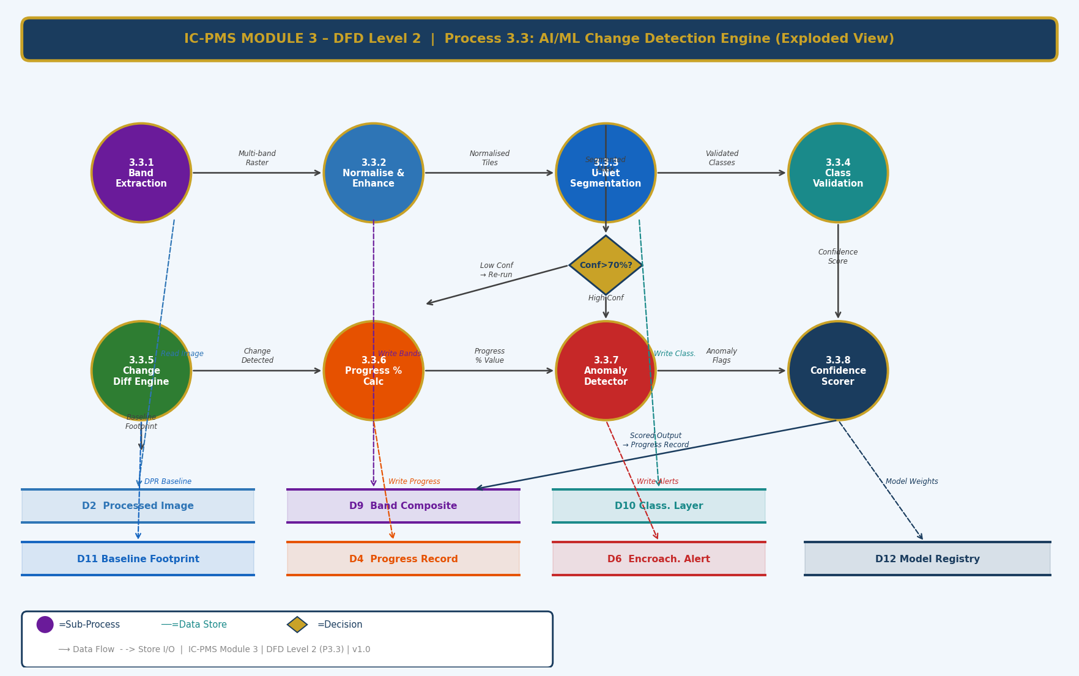
Figure 3.3 — DFD Level 2: Process 3.3 AI/ML Change Detection Engine — 8 Sub-Processes

Sub-Process Narrative
Sub-Process | Name | Description
3.3.1 | Band Extraction | Reads the processed GeoTIFF from D2 and extracts individual spectral bands required for classification: Red, Green, Blue, NIR (near-infrared). For SAR imagery (RISAT-2B), extracts backscatter channels (VV, VH). Writes extracted band stack to D9 (Band Composite).
3.3.2 | Normalise & Enhance | Applies per-band normalisation to [0,1] range using pre-computed training dataset statistics (mean and std). Applies CLAHE (Contrast Limited Adaptive Histogram Equalisation) to enhance edge detail for building and road detection. Output: normalised 4-band input tensor.
3.3.3 | U-Net Segmentation | Passes normalised 512×512 tiles through the trained U-Net-ResNet50 model. Output: 8-channel probability map (one per class) per tile. Tiles with cloud mask coverage > 30% are skipped. GPU inference on NIC MeghRaj A100 cluster; 4.2 min average per full WBS polygon.
3.3.4 | Class Validation | Applies argmax to probability maps to produce hard class labels. Checks confidence: pixels with max class probability < 70% threshold are reclassified as 'Uncertain'. If uncertain pixel proportion > 25% of polygon area, re-orders higher-resolution scene and suspends progress update for this data date.
3.3.5 | Change Diff Engine | Compares current classification raster against the DPR baseline footprint (read from D11) to compute change vectors: newly built area, demolished area, vegetation clearance, and area returning to idle. Outputs change polygons in GeoJSON for display in the GIS viewer.
3.3.6 | Progress % Calculator | Sums pixel area for active construction classes (CLS-01 to CLS-05). Divides by total DPR approved footprint area. Applies 3-scene rolling average. Compares against contractor-claimed % from Module 2. If |AI – Contractor| > 10%, writes discrepancy flag to D4 and triggers PMC review notification.
3.3.7 | Anomaly Detector | Runs three parallel anomaly checks: (a) Temporal check — CVI = 0 for 2+ scenes → Idle Zone alert; (b) Spatial check — active pixels outside DPR boundary polygon → Encroachment alert; (c) NTL check — night-time light spike > 3σ above baseline → Night Activity alert. All alerts written to D6.
3.3.8 | Confidence Scorer | Computes overall confidence score for the scene's AI output: Radiometric quality score (0–100) × Model confidence score (mean max-prob across valid pixels) × Temporal consistency score (correlation with previous 3 scenes). Final confidence score written to D4 alongside AI progress %.

4. Master Data Model

4.1 Entity Relationship Overview
The Module 3 master data model contains twelve entities. The Satellite Scene is the entry-point entity; the Processing Job, Classification Layer, and Satellite Progress entities form the core analytical pipeline. Encroachment Alerts, Anomaly Records, Vegetation Index records, and Drone Assets are lateral analytical outputs. The ML Model Registry tracks model versioning and accuracy over time.
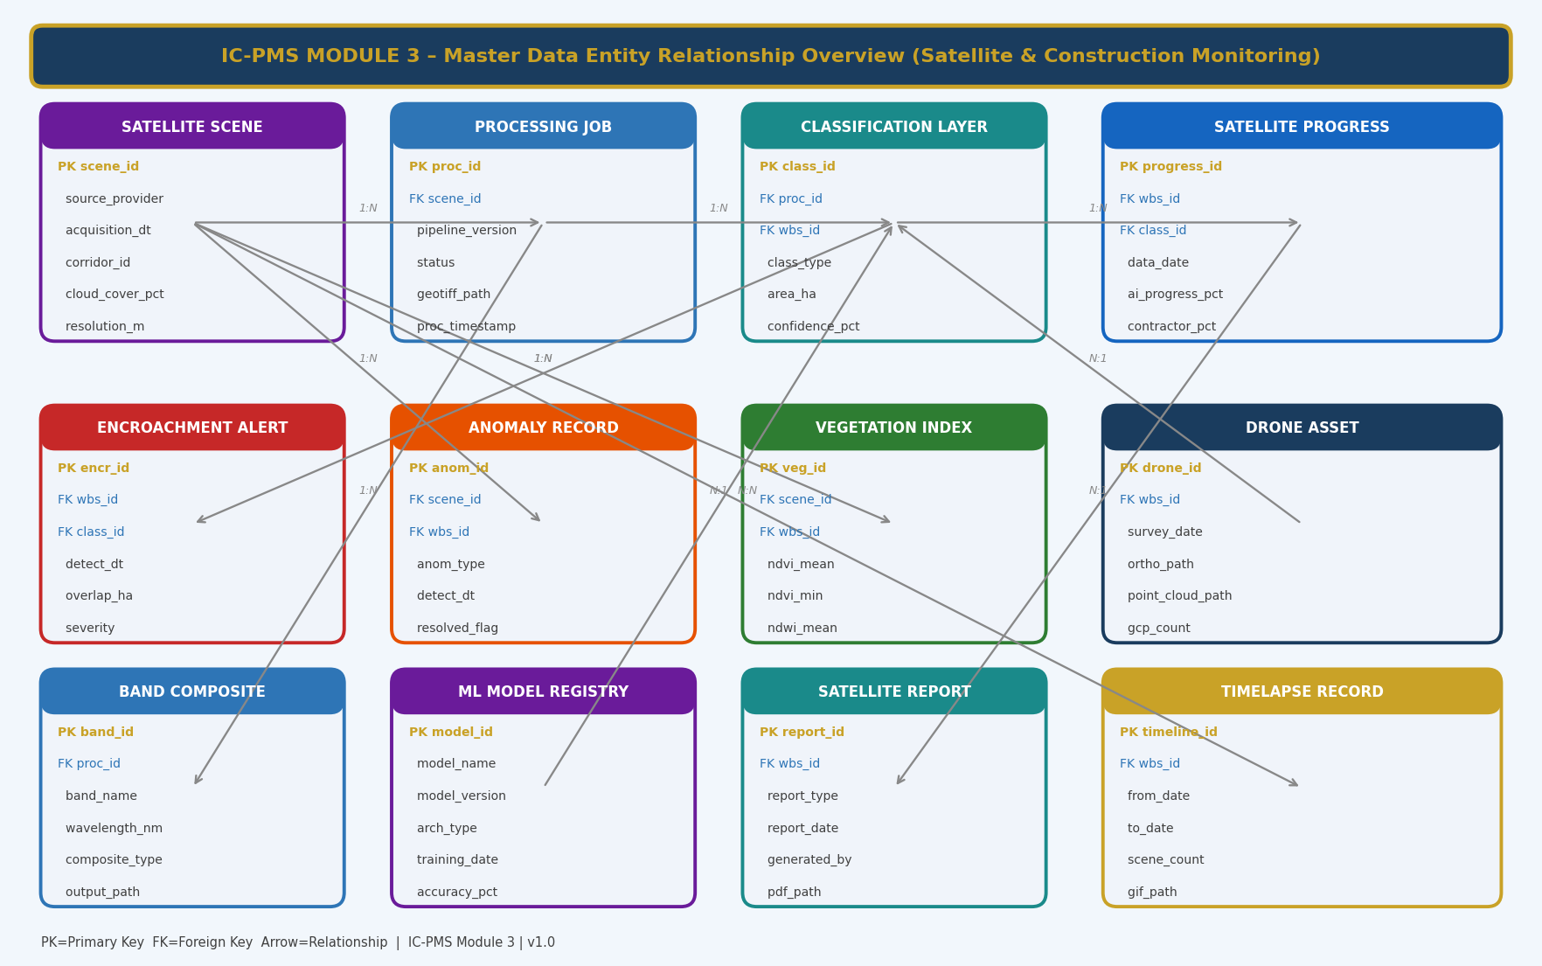
Figure 4.1 — Master Data Entity Relationship Overview (Module 3 — Satellite & Construction Monitoring)

4.2 Core Entity Field Definitions

4.2.1 Satellite Scene
scene_id | UUID — Primary Key; auto-generated on ingestion
source_provider | ENUM: ISRO_CARTOSAT3 / ISRO_RESOURCESAT2A / PLANET_SKYSAT / MAXAR_WV3 / ESA_SENTINEL2 / ISRO_RISAT2B
acquisition_dt | TIMESTAMP WITH TIME ZONE — exact acquisition datetime in UTC (stored) and IST (displayed)
corridor_id | FK → Module 1 Corridor Master — corridor covered by this scene
wbs_scope_json | JSONB — list of WBS IDs covered by this scene footprint
cloud_cover_pct | DECIMAL(5,2) — cloud cover % over the WBS polygon (not full scene)
resolution_m | DECIMAL(5,2) — ground sampling distance in metres
raw_storage_path | VARCHAR — NIC MeghRaj object storage path to raw scene files
scene_footprint | GEOMETRY(Polygon,4326) — scene boundary in WGS84 (PostGIS)
quality_score | INTEGER 0–100 — automated radiometric quality assessment score
ingestion_status | ENUM: Ordered / Downloading / Ingested / QC_Passed / QC_Failed / Processing
scene_date | DATE — the ground acquisition date (used for progress date alignment)

4.2.2 Processing Job
proc_id | UUID — Primary Key
scene_id | FK → Satellite Scene
pipeline_version | VARCHAR — e.g. 'pipeline-v2.4.1' — tracks processing software version
status | ENUM: Queued / Running / Completed / Failed / Re-queued
atmo_correction_method | ENUM: DOS / FORCE / LaSRC / None (for SAR)
pansharp_method | ENUM: Gram-Schmidt / Brovey / None
dem_source | ENUM: SRTM30 / CartoDEM30 / None
geotiff_path | VARCHAR — path to analysis-ready GeoTIFF in object storage
tile_count | INTEGER — number of 512×512 tiles generated
proc_timestamp | TIMESTAMP — when processing pipeline completed
proc_duration_min | DECIMAL — processing time in minutes for performance monitoring
wmts_layer_id | VARCHAR — GeoServer layer ID for map tile serving

4.2.3 Classification Layer
class_id | UUID — Primary Key
proc_id | FK → Processing Job
wbs_id | FK → WBS Element (the polygon this classification covers)
model_id | FK → ML Model Registry — model used for this inference
class_raster_path | VARCHAR — path to per-pixel classification GeoTIFF (INT8, 1 band, class values 1–8)
confidence_raster_path | VARCHAR — path to per-pixel confidence GeoTIFF (FLOAT32, values 0.0–1.0)
class_type | ENUM: U-Net / SAR-CNN / Manual-Override — inference method used
area_by_class_json | JSONB — {'cls01_ha': 34.2, 'cls02_ha': 18.7, ... } area in Ha per class
uncertain_area_pct | DECIMAL — % of polygon pixels below confidence threshold
inference_duration_min | DECIMAL — GPU inference time for monitoring
scene_date | DATE — inherited from source scene; used for temporal queries
data_date | DATE — Module 2 data date this classification serves

4.2.4 Satellite Progress Record
progress_id | UUID — Primary Key
wbs_id | FK → WBS Element
class_id | FK → Classification Layer — source classification for this progress figure
data_date | DATE — EVM data date this progress record applies to
ai_progress_pct | DECIMAL(5,2) — AI-derived physical % complete (3-scene rolling average)
raw_ai_pct | DECIMAL(5,2) — single-scene AI % (before rolling average)
contractor_pct | DECIMAL(5,2) — contractor-claimed % complete (from Module 2 progress log)
pmc_certified_pct | DECIMAL(5,2) — PMC-certified override % (NULL if no override)
authoritative_pct | DECIMAL(5,2) — the % used for EVM BCWP: pmc_certified_pct if set, else ai_progress_pct
discrepancy_flag | BOOLEAN — true if |ai_progress_pct – contractor_pct| > 10%
discrepancy_pct | DECIMAL(5,2) — (contractor_pct – ai_progress_pct); positive = contractor over-claiming
confidence_score | DECIMAL(5,2) — overall AI confidence 0–100 for this scene
override_reason | TEXT — PMC justification if pmc_certified_pct overrides ai_progress_pct
override_approved_by | FK → User — PMC engineer who approved the override

4.2.5 Encroachment Alert
encr_id | UUID — Primary Key
wbs_id | FK → WBS Element where encroachment is detected
class_id | FK → Classification Layer — source scene and classification
alert_type | ENUM: DPR_BOUNDARY_BREACH / ADJACENT_WBS_OVERLAP / ENV_BUFFER_VIOLATION / NIGHT_ACTIVITY / IDLE_ZONE / VEGETATION_OVERRUN / UNREGISTERED_EQUIPMENT
detect_dt | TIMESTAMP — when the alert was generated by the Anomaly Detector
overlap_ha | DECIMAL — area of encroachment in hectares
overlap_geojson | TEXT — GeoJSON of the encroachment polygon for map display
severity | ENUM: Critical / High / Medium / Low
ai_confidence | DECIMAL(5,2) — AI confidence in the encroachment detection
evidence_pdf_path | VARCHAR — path to auto-generated evidence PDF in Module 6 DMS
status | ENUM: Open / Assigned / Under_Investigation / Surveyor_Verified / Resolved / Escalated
assigned_to | FK → User — investigator assigned
resolution_dt | TIMESTAMP — when status moved to Resolved
resolution_notes | TEXT — description of resolution action taken

4.2.6 ML Model Registry
model_id | UUID — Primary Key
model_name | VARCHAR — e.g. 'UNet-ResNet50-IndiaConstruction-v2.3'
model_version | VARCHAR — semantic version
arch_type | ENUM: U-Net / DeepLabV3+ / SAR-CNN / Ensemble
encoder_backbone | VARCHAR — e.g. 'ResNet-50', 'EfficientNet-B4'
training_date | DATE — when model was last trained
training_scenes | INTEGER — number of training tiles used
validation_miou | DECIMAL(5,2) — mean Intersection over Union on validation set
class_accuracies_json | JSONB — per-class IoU values
model_weights_path | VARCHAR — path to .pth model file on MLflow / object storage
status | ENUM: Candidate / Active / Deprecated
deprecated_date | DATE — when model was retired; NULL if still active
retraining_trigger | VARCHAR — reason for retraining (accuracy drop / new class / new sensor)

5. UI/UX Screen Designs
Module 3 delivers five primary screens. The Map Dashboard is the central operational workspace — combining satellite imagery with WBS polygon analytics in a GIS-native interface. The Timelapse Viewer, AI Analytics screen, Encroachment Alert Manager, and Report Generator support the analytical and reporting workflows. All screens are designed for the dual audience of field-oriented GIS specialists (needing spatial precision) and executive-level NICDC officials (needing instant status clarity). Dark-themed map screens adopt a deep navy-black background to maximise satellite imagery contrast; analytical screens use the standard light theme.

Screen 1 — Satellite Map Dashboard
The Map Dashboard is the first screen users see when entering Module 3. It shows the current satellite view of the entire corridor with WBS polygons colour-coded by AI-derived progress, live encroachment markers, and a right-panel scene information panel for the selected polygon. The screen functions as both a strategic overview and a drill-down tool.
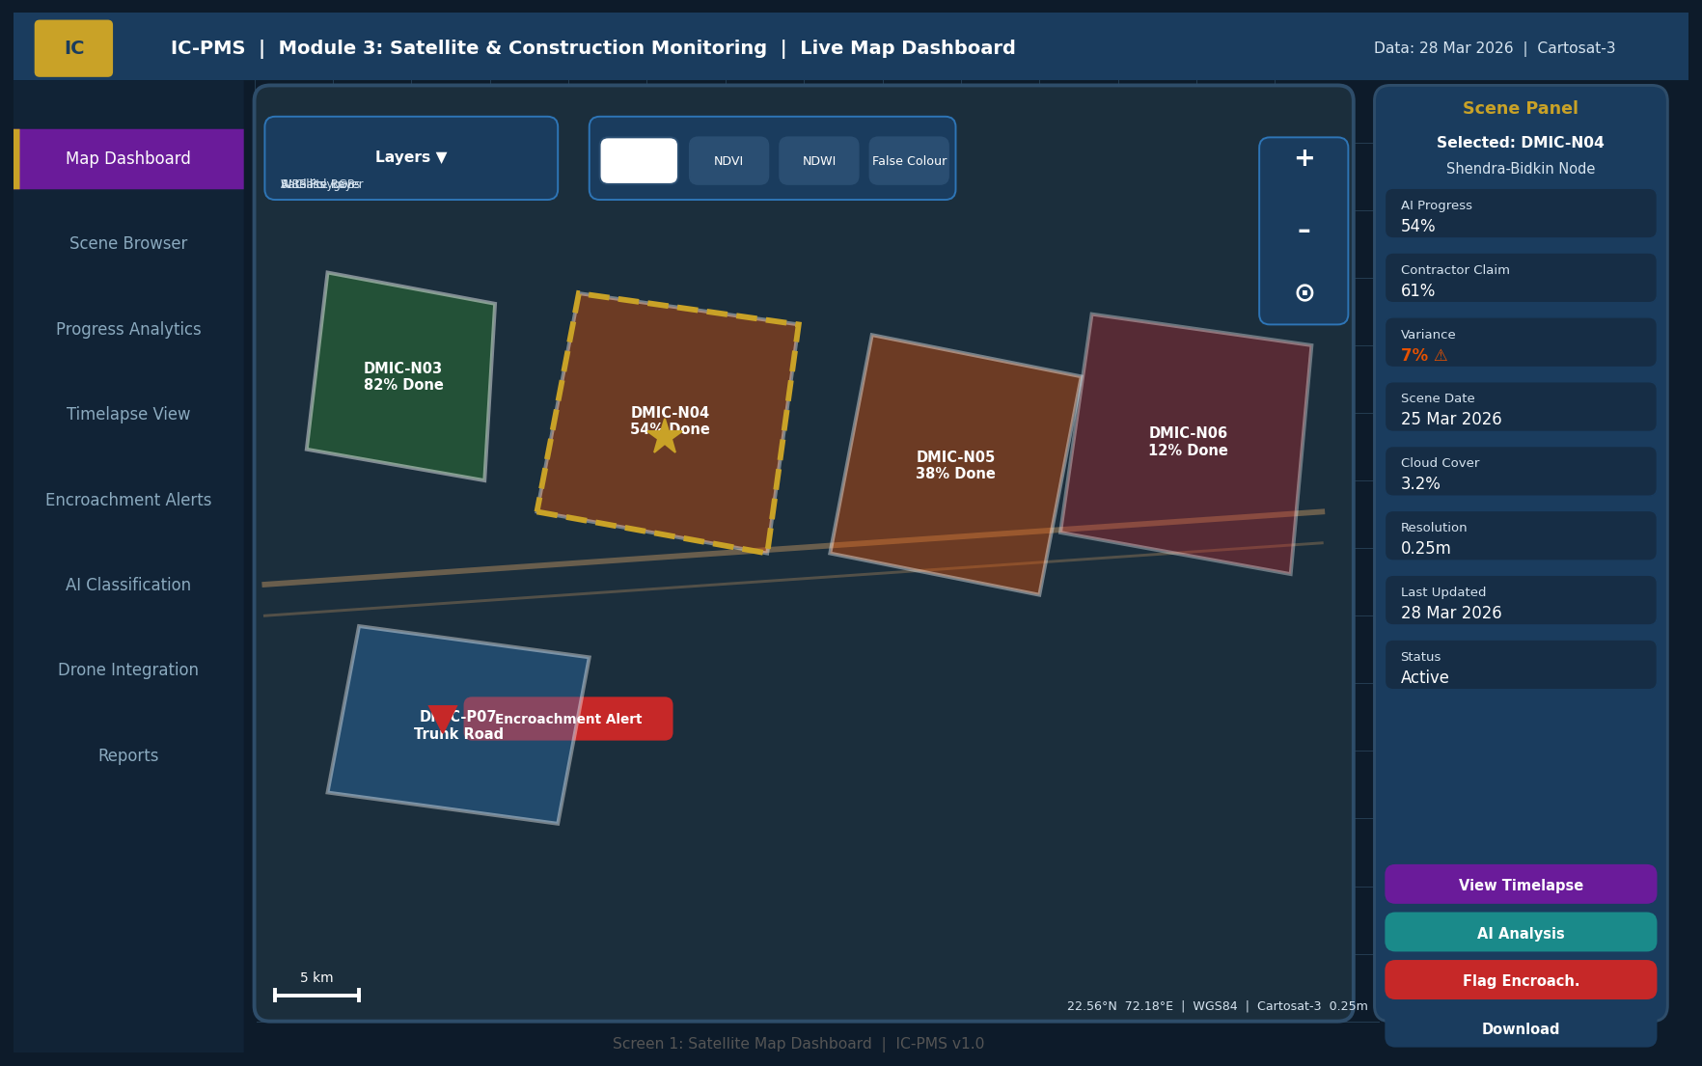
Figure 5.1 — Satellite Map Dashboard (WBS Polygon Overlay, AI Progress Coding, Scene Panel, Layer Controls)

Map Dashboard UI Components
Component | Description | Interaction
WBS Polygon Overlay | Semi-transparent filled polygons colour-coded by AI progress: Green>80%, Teal 60–80%, Blue 40–60%, Orange 20–40%, Red<20%. Gold dashed border = currently selected. | Click polygon to load Scene Panel; hover for tooltip (WBS code, AI %, date)
Satellite Base Map | Processed WMTS tiles from GeoServer; default RGB; switchable to NDVI/NDWI/False Colour/SWIR | Band selector buttons in top bar; tile updates without page reload
Corridor Alignment Line | Gold polyline showing corridor road/rail centreline for spatial reference | Non-interactive; toggled via layer control
Encroachment Markers | Red inverted triangle markers at encroachment locations; clicking loads alert detail | Click to open Encroachment Alert panel (Screen 4)
Scene Panel (right) | For selected polygon: AI Progress, Contractor claim, Variance, Scene date, Cloud cover, Resolution, Encroachment status. Action buttons: View Timelapse, AI Analysis, Flag, Download. | Each action button navigates to relevant screen or triggers download
Layer Control | Toggles: WBS Polygons, Satellite RGB, AI Classification Layer, DPR Boundary, Admin Boundaries | Checkbox list; active layers rendered in stated order
Band Selector | 4 quick buttons: RGB, NDVI, NDWI, False Colour | Single-click; active button highlighted gold
Map Controls | Zoom +/–, centre on current location, north arrow, scale bar, coordinate display | Standard MapLibre GL controls; coordinate shown at mouse position

Screen 2 — Temporal Comparison & Timelapse Viewer
The Timelapse Viewer shows two satellite images of the same WBS polygon side by side from different dates, with construction progress visually apparent from the imagery. A timeline scrubber at the bottom allows users to navigate through all available acquisition dates. A statistics bar shows quantified change metrics between the two selected dates.
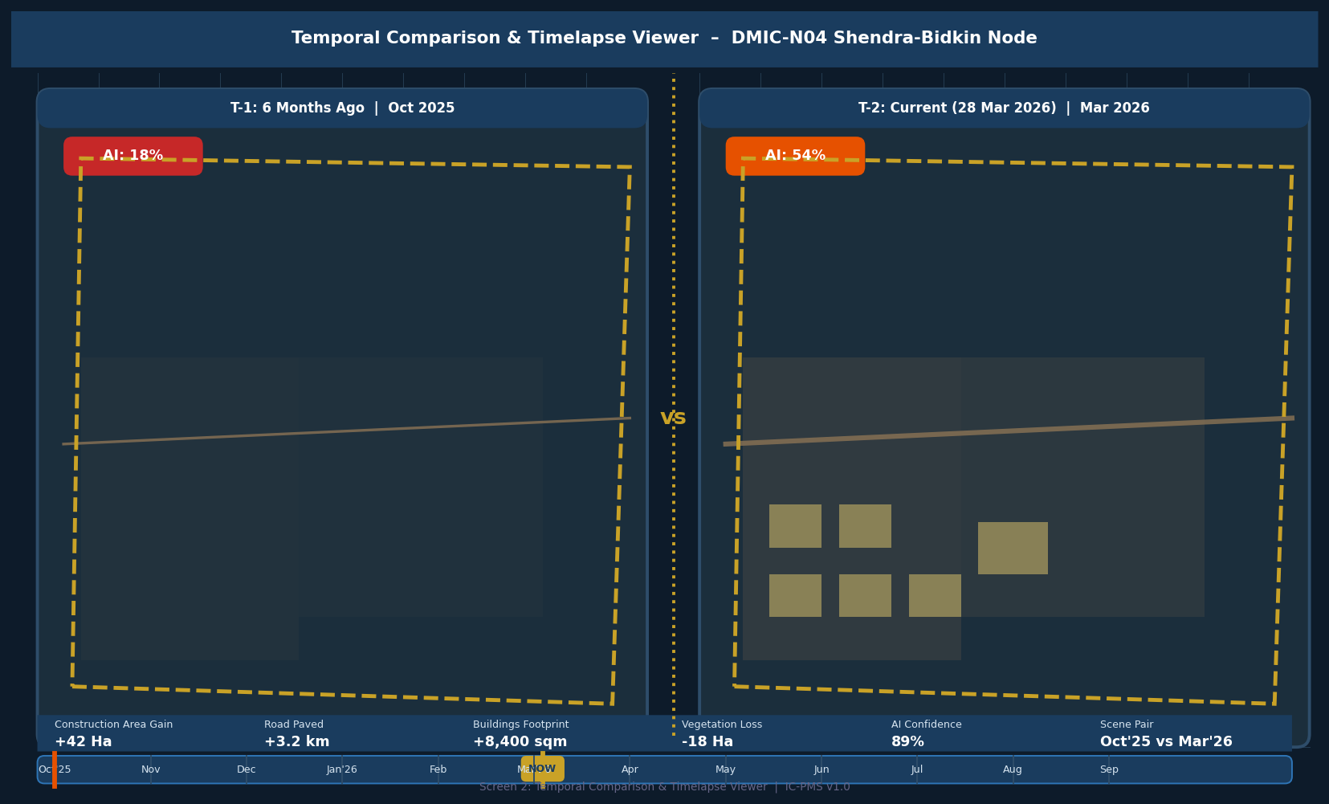
Figure 5.2 — Temporal Comparison Viewer (Side-by-Side Imagery, Timeline Scrubber, Change Statistics Bar)

Timelapse Viewer UI Features
Feature | Description
Side-by-side panels | Left panel = user-selected past date; Right panel = current scene. Both panels show same spatial extent of selected WBS polygon.
Timeline scrubber | Horizontal bar with tick marks for each available acquisition date. Drag left handle = past date, right handle = current. Date labels shown at ticks. TODAY marker on current date.
Change statistics bar | Row of metrics between the two dates: Construction Area Gain (Ha), Road Paved (km), Building Footprint (sqm), Vegetation Loss (Ha), AI Confidence %, Scene Pair label.
WBS boundary overlay | Gold dashed polygon overlay on both panels showing the DPR-approved WBS boundary for spatial reference.
Progress badge | Coloured badge in top-left of each panel showing AI-derived progress % at that date (Green/Amber/Red).
Animate button | Cycles through all available scenes as an animation (2 fps); generates and downloads animated GIF on 'Export' click.
Split-view slider | Vertical line draggable horizontally across a single panel to compare two dates in the same view (swipe comparison).
Zoom lock | Both panels zoom and pan synchronously when Zoom Lock is enabled; independently when disabled.

Screen 3 — AI/ML Classification Analytics
The AI Analytics screen provides a deep dive into the classification results for a selected WBS polygon — showing the breakdown of detected construction classes, a monthly progress trend comparing AI-derived vs. contractor-claimed values, a class confusion/confidence matrix, and full scene metadata.
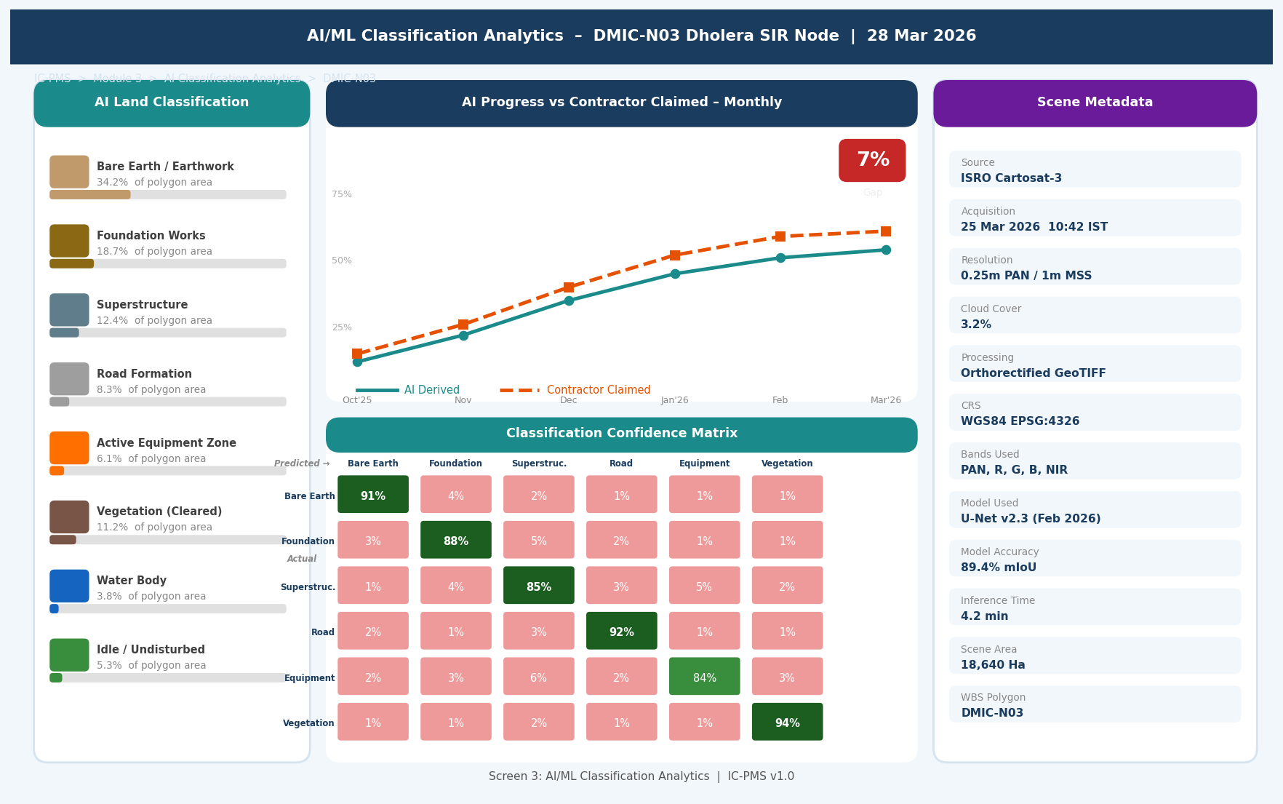
Figure 5.3 — AI Classification Analytics (Class Breakdown, AI vs. Contractor Trend, Confidence Matrix, Scene Metadata)

AI Analytics Screen Components
Component | Description | Key Information
Class Breakdown Panel (left) | 8 horizontal bars showing % of polygon area covered by each construction class. Each bar colour-coded to class (brown=earthwork, grey=superstructure, etc.) | Immediately shows what type of work is dominant — key for PMC review of contractor claims
AI vs. Contractor Trend Chart | Line chart with monthly AI-derived progress (teal line) vs. contractor-claimed progress (orange dashed). Shaded red area between lines = discrepancy. Current data point highlighted. | Trend over 6 months reveals systematic over-claiming patterns; used as evidence in RA Bill disputes
Discrepancy Badge | If AI and contractor differ by >10%: prominent red badge showing the gap percentage, positioned adjacent to current data point on trend chart. | Immediate visual alert for PMC review; clicking opens override workflow
Confidence Matrix | Heat map showing accuracy of AI classifications (predicted vs. actual) using PMC-verified ground truth samples. Green=high accuracy, Red=low accuracy. | Helps PMC engineers assess which classes to trust and which need field verification
Scene Metadata Panel (right) | Source satellite, acquisition datetime, resolution, cloud cover, processing pipeline version, model used, model accuracy, inference time, WBS polygon area. | Complete provenance trail for audit and dispute resolution — 'chain of custody' for AI evidence

Screen 4 — Encroachment Detection & Anomaly Alert Manager
The Encroachment Manager is the operational hub for all spatial compliance monitoring. It displays all active alerts across the corridor in a filterable table, with severity colour-coding, SLA status, and one-click escalation. The detail panel at the bottom shows AI evidence for the selected alert.
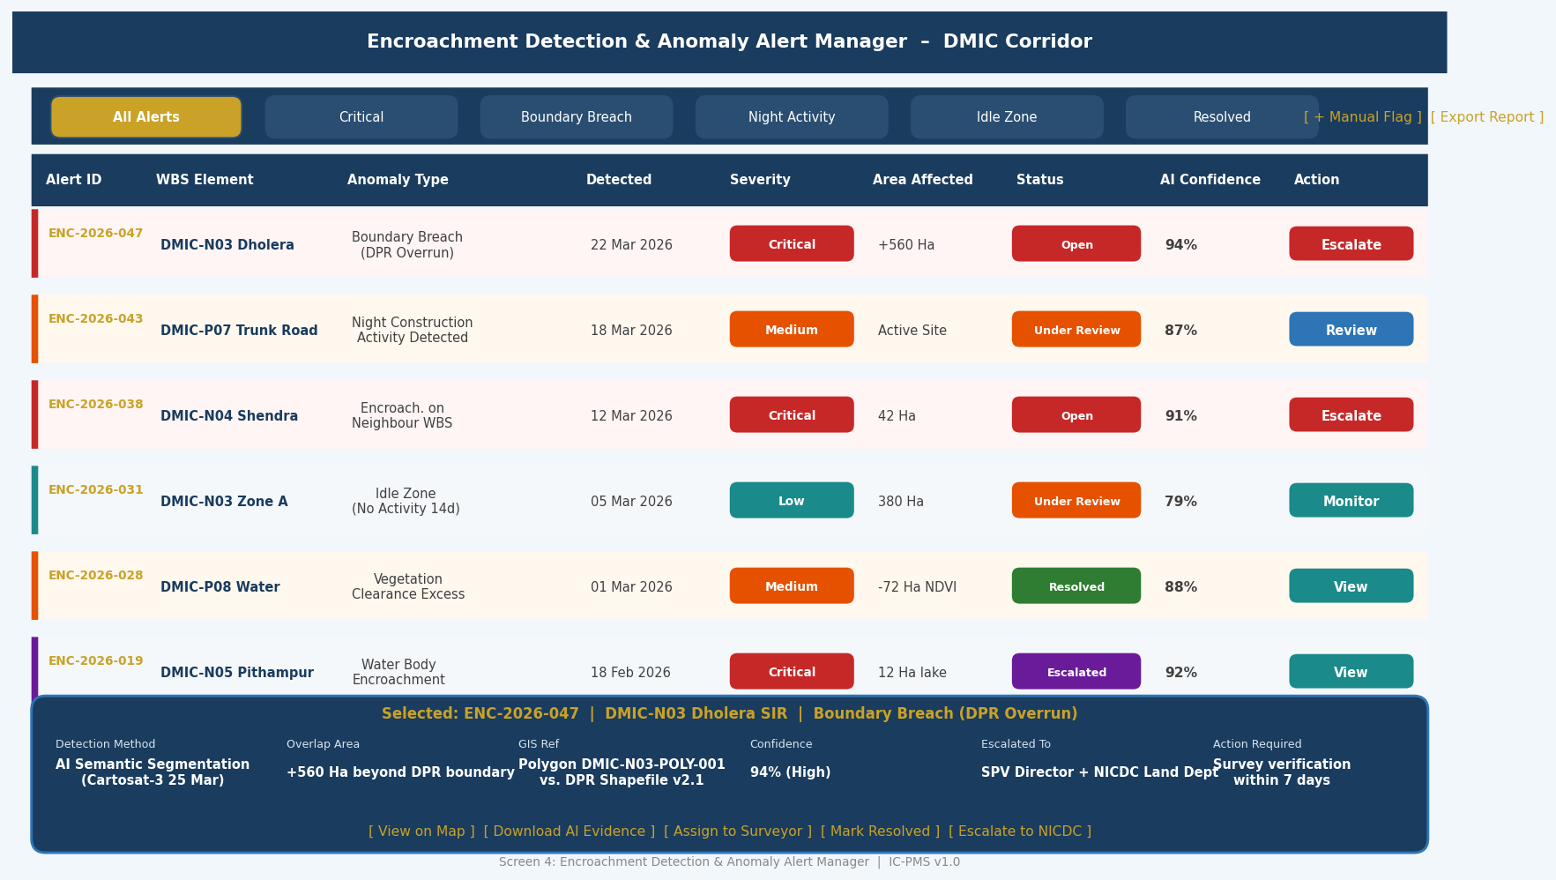
Figure 5.4 — Encroachment Alert Manager (Alert Table, Severity Filters, AI Evidence Detail Panel)

Alert Manager UI Design Decisions
- Left severity stripe: A coloured vertical stripe on the left edge of each row provides instant severity recognition without needing to read the Severity column — red for Critical, orange for Medium, teal for Low
- Action column: The rightmost column shows a single primary action button per alert (Escalate/Review/Monitor/View) — reducing the cognitive load of deciding what to do next
- SLA countdown: For Open and Under Investigation alerts, a countdown timer shows hours/days remaining before SLA breach; turns red when < 20% of SLA time remains
- Bulk actions: Checkbox select multiple alerts; bulk assign, bulk escalate, or bulk export evidence package
- Detail panel: Fixed at bottom; loads instantly on row click without navigating away; shows full AI evidence, coordinates, overlap polygon, and action buttons
- Search and sort: Full-text search across Alert ID, WBS name, anomaly type; sort by date, severity, confidence, or area

Screen 5 — Satellite Analytics Report Generator
The Report Generator screen provides a configuration panel and live report preview. Users can select report type, scope, period, and content options; a scrollable preview shows exactly what the report will contain before generation. Scheduled reports run automatically but this screen enables on-demand generation with custom parameters.
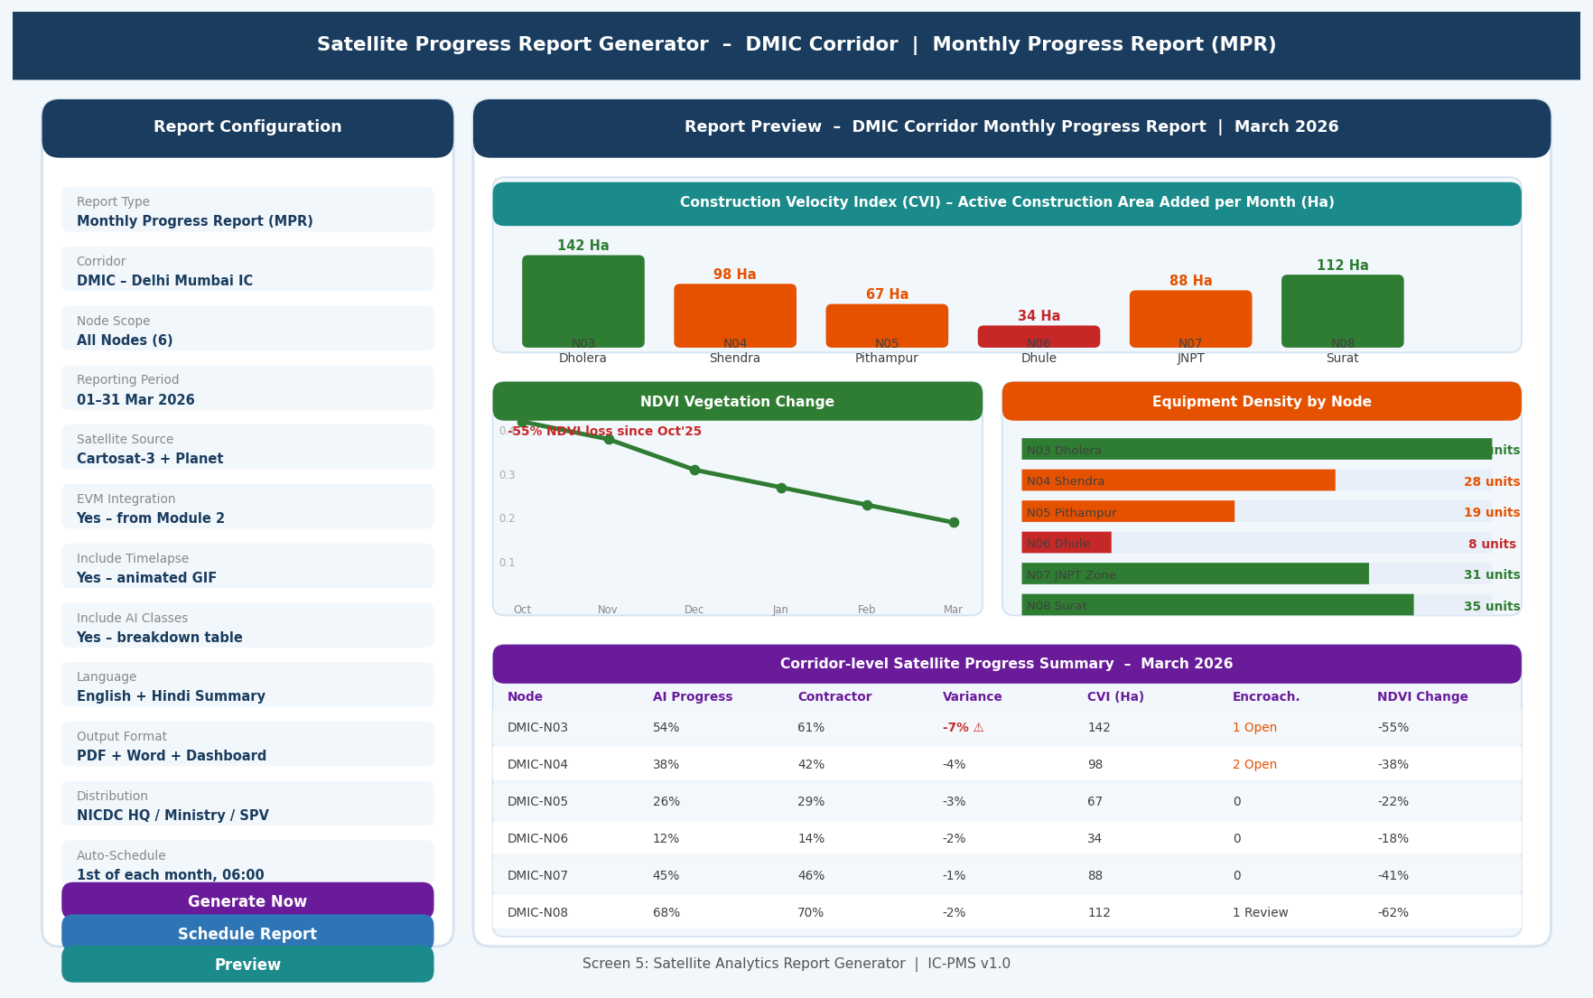
Figure 5.5 — Satellite Analytics Report Generator (Configuration Panel, Report Preview with CVI, NDVI, Equipment Density, Progress Table)

Report Preview Components
Preview Section | Contents | Chart Type
Construction Velocity Index (CVI) | Bar chart showing active construction area added per month (Ha) per node. Colour: Green>100Ha, Orange 60–100, Red<60. | Vertical bar chart; each bar represents one node
NDVI Vegetation Change Trend | Line chart showing mean NDVI value across corridor for each month since project start. Fill area under line shows loss from baseline. | Area chart; green fill; red annotation for % loss
Equipment Density by Node | Horizontal bar chart showing AI-detected equipment count per active Ha; nodes sorted highest to lowest. | Horizontal stacked bar; Green>1.0/Ha, Orange 0.5–1.0, Red<0.5
Corridor Progress Summary Table | Table: Node, AI Progress, Contractor Claim, Variance, CVI, Encroachments Open, NDVI Change. Row colour-coded by worst metric. | Structured table; cell-level colour coding
Timelapse Thumbnails | Animated GIF thumbnail for each active node (6-month sequence, 3fps). Shown as still with 'Play' overlay in PDF; embedded animation in HTML version. | Animated GIF / static thumbnail

6. Business Rules & Validation Logic

6.1 Scene Acquisition Rules
Rule ID | Description | Action
SAT-001 | Cloud cover over the WBS polygon must be < 20% for a scene to be accepted for processing | Auto-reject scene; trigger re-order for next available acquisition window
SAT-002 | Scene acquisition date must be within 10 days of the current EVM data date for progress to be credited to that data date | Scene processed but progress % deferred to next data date if date gap > 10 days
SAT-003 | Minimum scene resolution must be ≤ 1m for construction classification; coarser imagery used only for NDVI/NDWI analysis | Coarser scenes (Sentinel-2) auto-routed to vegetation analytics pipeline only
SAT-004 | For each WBS polygon at Construction phase, at least 2 scenes must be ingested per month to maintain rolling average validity | Alert to satellite operations team if coverage drops below 2 scenes/month
SAT-005 | ISRO Cartosat-3 must be attempted first before commercial providers for any scene order; commercial orders only placed if ISRO scenes are rejected for cloud cover or outage | System logs commercial scene cost and reason for ISRO non-availability for budget tracking

6.2 AI/ML Rules
Rule ID | Description | Action
AI-001 | If uncertain pixel proportion in a polygon > 25%, AI progress figure is marked 'Low Confidence' and not used for EVM BCWP; PMC must provide certified progress | EVM holds previous progress %; PMC alert sent; high-resolution scene re-ordered
AI-002 | If |AI progress % – Contractor claimed %| > 10%, a discrepancy flag is raised and PMC must review within 5 working days | Invoice approval for that WBS package blocked until PMC resolves discrepancy
AI-003 | PMC override of AI-derived progress must include: field inspection date, inspector name, photographic evidence uploaded to Module 6 DMS, minimum 50-character justification | Override without evidence automatically rejected; second PMC-level approval required for override > 15%
AI-004 | Model accuracy (validation mIoU) must be checked monthly; if accuracy drops below 85%, model retraining is triggered before next data date AI run | Operations alert; fallback to previous model version until retraining completed
AI-005 | All PMC overrides are automatically included as new labelled training samples in the next model retraining cycle to continuously improve accuracy | Override data automatically tagged with metadata for supervised fine-tuning

6.3 Encroachment Rules
Rule ID | Description | Action
ENC-001 | Any construction pixel detected outside the DPR-approved WBS boundary polygon by more than 50m spatial tolerance automatically generates a Critical encroachment alert | Alert created in D6; evidence PDF auto-generated; SPV Director and NICDC Land Dept notified within 24 hours
ENC-002 | Critical encroachment alerts unresolved after 7 days auto-escalate to NICDC Programme Director | Escalation notification sent; alert status changed to Escalated; invoice approval for WBS package blocked
ENC-003 | Environmental buffer violation alerts (CRZ, forest boundary, wetland) are simultaneously forwarded to the NICDC Environmental Cell for MoEFCC notification | Dual notification: internal alert in IC-PMS + external email to MoEFCC portal via NeSDA API
ENC-004 | Resolved encroachment alerts must be supported by a surveyor-verified field measurement uploaded to Module 6 DMS before the alert can be closed | System rejects 'Resolved' status without evidence document; PMC Director counter-approval required

7. Integration Touchpoints

7.1 Internal Module Integrations
Module | Data Exchanged | Trigger / Frequency
Module 1 — WBS & GIS | Inbound: WBS geo-polygon boundaries (GeoJSON), DPR boundary shapefiles, Corridor/Node/Package codes; Outbound: AI progress % per WBS element, Encroachment flag per polygon, Classified WMTS layer endpoint | Weekly scene processing cycle; real-time polygon boundary updates when Module 1 WBS is republished
Module 2 — Scheduling | Inbound: EVM data date, Activity scope list for progress update; Outbound: Authoritative physical % complete (pmc_certified_pct or ai_progress_pct) for BCWP calculation | On data date advance in Module 2; AI progress pushed to Module 2 Progress Store within 24 hours of scene processing
Module 4 — Cost Management | Outbound: AI progress milestone triggers for invoice validation (satellite-verified progress gates invoice approval before PFMS payment) | Per RA Bill cycle; system validates AI progress ≥ contractor-claimed % at invoice date before approval
Module 6 — DMS | Outbound: Evidence PDFs for encroachment alerts, Satellite Progress Reports, Certified timelapse GIFs, Scene metadata for audit trail | Automated on alert generation and report generation; documents auto-filed under relevant WBS folder
Module 9 — Reporting | Outbound: CVI values, NDVI index, AI progress %, equipment density, encroachment count per WBS — all for executive dashboard and MPR | Real-time REST API read; data refreshed every 24 hours after nightly satellite processing run

7.2 External System Integrations
System | Integration Type | Data Flow | Notes
ISRO Bhuvan / NRSC STAC | REST API (STAC Catalog) | Scene metadata query and GeoTIFF download; WBS AOI submitted as spatial filter | OAuth 2.0; rate-limited to 500 requests/day; ISRO Data Policy compliance
Planet Labs API | REST API (Planet Orders API) | Commercial scene ordering with AOI polygon; GeoTIFF delivery to NIC storage | Only used when ISRO unavailable; cost tracked per scene; Planet Education & Research licence
Maxar Streaming API | WMTS + REST | Streaming WMTS tiles for map display; on-demand GeoTIFF for milestone verification | Used for critical milestone photography; cost approved per event by NICDC Finance
NOAA/NASA VIIRS NTL | FTP / Open Data API | Monthly Night-Time Light raster tiles for anomaly detection | Global public dataset; updated monthly; auto-downloaded for Indian corridor bounding boxes
MoEFCC PARIVESH | REST API | Environmental clearance polygon boundaries for buffer zone definition; encroachment violation notifications | Webhook subscription for clearance boundary updates; notification API for violations
GeoServer (internal OGC) | OGC WMS/WMTS/WFS | All satellite rasters and WBS vector layers served as OGC tiles to IC-PMS map viewer | Internal NIC deployment; PostGIS as spatial database; GeoServer 2.23+
MLflow (internal) | REST API | Model registry — fetch active model weights, log training runs, store accuracy metrics | Internal NIC MeghRaj deployment; all model artefacts stored on sovereign cloud

8. Operational Workflows

8.1 Weekly Satellite Processing Cycle
Step | Day/Time | Process | System Actor
1 | Friday 18:00 | Scene ordering: API calls to ISRO and commercial providers for all active WBS polygons; cloud-cover forecast checked | Automated — Kubernetes CronJob
2 | Saturday 00:00–06:00 | Scene download: GeoTIFFs pulled from provider APIs to NIC MeghRaj; quality check run | Automated — Download Manager
3 | Saturday 06:00–18:00 | Image processing pipeline: Atmospheric correction, orthorectification, pansharpening, tiling, band composites | Automated — GDAL/OTB pipeline
4 | Sunday 00:00–08:00 | AI/ML inference: U-Net segmentation on all new tiles; confidence scoring; classification rasters generated | Automated — PyTorch GPU cluster
5 | Sunday 08:00–12:00 | Analytics computation: AI progress %, CVI, NDVI, EDI computed; contractor comparison run; discrepancy flags raised | Automated — Analytics Engine
6 | Sunday 12:00 | Anomaly and encroachment detection: Spatial intersection, NTL check, idle zone check; alerts generated in D6 | Automated — Anomaly Detector
7 | Monday 06:00 | WMTS layer update: New classified and processed imagery published to GeoServer; IC-PMS map viewer refreshed | Automated — GeoServer REST API
8 | Monday 08:00 | Progress data available: Authoritative AI progress % available in Module 2 for data date advance; discrepancy alerts sent to PMC | Module 2 data date advance by NICDC PM

8.2 Discrepancy Resolution Workflow
Step | Actor | Action | Timeline
1 | Automated System | Discrepancy flag raised when |AI% – Contractor%| > 10%; PMC alert email + IC-PMS notification sent | Immediately on analytics computation
2 | PMC Site Engineer | Reviews AI classified image against site knowledge; checks if satellite view is obscured by scaffolding/roofing | Within 2 working days
3a | PMC (accepts AI) | Confirms AI-derived progress as authoritative; contractor RA Bill value may be reduced accordingly | Day 3
3b | PMC (overrides AI) | Provides field inspection report, photos, MB quantities as override evidence; enters certified % with justification | Day 3–5; second PMC approval required if override > 15%
4 | SPV PM | Reviews resolution; approves if within standard parameters; escalates to SPV Director if override > 20% or contractor disputes | Day 5
5 | System | Authoritative % updated in D4; Module 2 EVM recalculated; invoice approval gate updated | Immediately on SPV PM approval

9. Performance & Non-Functional Requirements
Requirement | Specification | Measurement Method
Scene ingestion to WMTS availability | < 4 hours from raw scene download to published WMTS tile | End-to-end pipeline timer; alert if > 4 hrs
AI inference speed | < 6 hours for a full 20,000 Ha polygon at 0.25m resolution | GPU cluster job completion log
Map tile load time | < 2 seconds to render all WBS polygons + satellite tiles for corridor view | MapLibre GL frame render time; P95 under 200 concurrent users
Encroachment alert latency | < 30 minutes from anomaly detection to alert notification delivery | Alert creation timestamp vs. email delivery timestamp
AI model accuracy (mIoU) | ≥ 85% on monthly validation run; retraining triggered if below | MLflow accuracy log; monthly automated validation job
Data storage growth | < 500 GB/month per corridor for raw + processed imagery | NIC MeghRaj object storage monitoring
Report generation time | < 5 minutes for full MPR (all nodes) PDF | JasperReports job completion time
Scene availability SLA | ≥ 2 cloud-free scenes per WBS polygon per month | Monthly scene availability report per polygon
API uptime | 99.5% for GeoServer WMTS and progress API endpoints | Synthetic monitoring; monthly SLA report
Data retention | 30 years for raw scenes and classified outputs; 10 years for reports | Automated archival policy; NIC cold storage tier

10. Glossary — Module 3 Terms
Term | Definition
Semantic Segmentation | Per-pixel classification of an image into predefined categories (e.g., construction classes)
U-Net | Deep learning encoder-decoder architecture widely used for semantic segmentation of satellite and medical images
mIoU | Mean Intersection over Union — standard accuracy metric for semantic segmentation; measures overlap between predicted and actual class regions
GeoTIFF | Geographically-referenced TIFF image format containing embedded coordinate reference information
WMTS | Web Map Tile Service — OGC standard for serving pre-rendered map tiles for efficient web map display
STAC | SpatioTemporal Asset Catalog — open standard for describing and querying geospatial assets (satellite scenes)
NDVI | Normalised Difference Vegetation Index = (NIR–R)/(NIR+R); positive values indicate healthy vegetation
NDWI | Normalised Difference Water Index = (G–NIR)/(G+NIR); positive values indicate water bodies
CVI | Construction Velocity Index — IC-PMS metric for rate of new active construction area added per week (Ha/week)
EDI | Equipment Density Index — AI-detected count of construction equipment per Ha of active construction zone
NTL | Night-Time Light — satellite-derived measure of artificial light emission; proxy for human activity including night construction
DEM | Digital Elevation Model — raster representation of terrain surface elevations
DSM | Digital Surface Model — DEM including buildings, trees, and other surface features above ground
GCP | Ground Control Point — precisely surveyed point on the ground used to geometrically correct aerial/satellite imagery
RMSE | Root Mean Square Error — measure of georeferencing accuracy; target < 1 pixel for IC-PMS imagery
Orthorectification | Geometric correction of satellite imagery to remove terrain distortion using a DEM
Pansharpening | Process of fusing a high-resolution panchromatic band with lower-resolution colour bands to produce a high-resolution colour image
mIoU | Mean Intersection over Union — standard metric for semantic segmentation accuracy across all classes
SAR | Synthetic Aperture Radar — active microwave remote sensing; penetrates clouds and works at night
BOA | Bottom-of-Atmosphere reflectance — surface reflectance after atmospheric correction; used as model input

